NEXTAG COMPANY

**Online Exclusive Preview Gucci**

**1955 Horsebit bag**

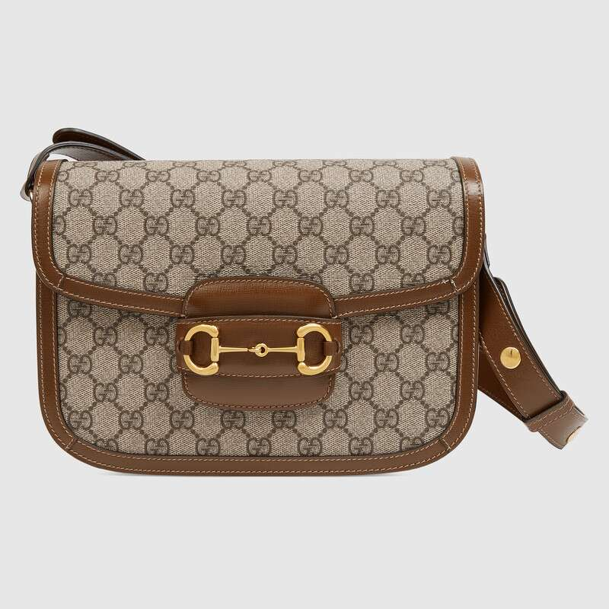

Style # 602204 92TCG 8563

Product Description

Introduced for Cruise 2020, the Gucci 1955 Horsebit bag is recreated from an archival design. With the same lines and forms first introduced over six decades ago, the accessory unifies the original details with a modern spirit, highlighting the Horsebit. Part of Gucci’s genetic code, the double ring and bar design has been established as one of the most distinctive elements among the House symbols borrowed from the equestrian world. Presented on a small flap shoulder bag, the hardware is paired with the House’s monogram fabric and completed with a special mechanism that adjusts the length of the shoulder strap so it can be carried on one shoulder or cross body.

Gold-toned hardware • Gucci 1955 Horsebit • Horsebit detail at the front

• Half Horsebit detail at each side

• Shoulder strap with snap buttons can be adjusted from a 9.8" to 17.7" drop

• Three gussets with one zipper and one open pocket • Flap closure • Made in Italy

PRODUCT DETAILS

Style ‎602204 92TCG 8563

Introduced for Cruise 2020, the Gucci 1955 Horsebit bag is recreated from an archival design. With the same lines and forms first introduced over six decades ago, the accessory unifies the original details with a modern spirit, highlighting the Horsebit. Part of Gucci’s genetic code, the double ring and bar design has been established as one of the most distinctive elements among the House symbols borrowed from the equestrian world. Presented on a small flap shoulder bag, the hardware is paired with the House’s monogram fabric and completed with a special mechanism that adjusts the length of the shoulder strap so it can be carried on one shoulder or cross body.

* A limited time online exclusive, this bag will be available with early access on Gucci.com
* Beige/ebony GG Supreme canvas, a material with low environmental impact, with brown leather trim
* Gold-toned hardware
* Microfiber lining with a suede-like finish
* Each bag will ship with a small pouch containing two additional button covers that can be used to cover the exposed studs when the shoulder strap is lengthened
* Horsebit detail at the front
* Half Horsebit detail at each side
* Three gussets with one zipper and one open pocket
* Shoulder strap with snap buttons can be adjusted from a 9.8" to 17.7" drop
* Flap closure
* Small size: 9.8"W x 7"H x 3.1"D
* The model is 5'8" tall
* Made in Italy